Post Details | Last Updated: 06/08/2024
Faculty/Administrative/Service  Department | Global / Marketing
Job Title | Student Marketing Coordinator
Job Family | Professional Services | Job Level | 3
Responsible to | Student Marketing Manager
Responsible for (Staff) | N/A
Job Purpose Statement

Working alongside the Student Marketing team, the post holder will provide support to develop, implement and evaluate innovative and effective recruitment marketing campaigns for the University, in alignment with the Department and University strategic objectives.
The post holder will assist the Student Marketing Manager to oversee the implementation of marketing plans through multiple integrated channel marketing activities including but not limited to, the creation of assets, promotional materials, recruitment of marketing student ambassadors and digital administrative tasks. The postholder will be an experienced copywriter and have the confidence to develop content across a number of marketing channels, from emails to social media, whilst supporting audience-led campaigns.
The position holder will be required to manage a busy schedule, be adaptable and able to prioritise workloads to ensure that the University’s student recruitment and brand reputation objectives are effectively met, planned and executed.
The post holder will work collaboratively with staff across the University to develop marketing campaigns, support with the coordination of marketing student ambassadors, and analyse and evaluate activity to inform future campaigns.

Key Responsibilities

1.Support the Student Marketing Manager and Head of Marketing with key campaigns across UG and PG, driving lead generation, brand awareness, engagement and conversion. This involves developing an engaging user experience that aligns to target audience needs and motivations, is informed by customer insight and is on time and within budget.

2.Support the Student Marketing team with the creative execution, production and delivery of key advertising campaigns, including development of creative briefs, media buying, media production which are correctly targeted and tailored to audiences. Including recruitment assets, materials, photography film, content, emails and printed items. Ensuring all creative and content meets brand identity guidelines and institutional tone of voice.

3. Work closely with the Student Marketing Manager, Recruitment and Social Media teams to recruit, train and work with Surrey student ambassadors as part of community of content generators for our social channels and third party platforms.

4.Working with the Student Marketing Manager to plan student generated content which aligns with the marketing campaigns, across brand and faculty. Manage all aspects of the marketing student ambassador programme, including training delivery, payroll, rotas, content plans, daily communication support and budget.

5.Lead and manage third party platforms to ensure content is up to date and accurate. Meet regularly with marketing student ambassadors to ensure they understand what is required of them at key touch points in the recruitment cycle. Feedback monthly on performance insights and present reports as required.

6.Work with the Student Marketing Manager and Recruitment teams to manage the Unibuddy Community Offer Holder groups.

7. Undertake regular monitoring and reporting on competitor activity, trends and any other duties required by the Student Marketing Manager and Head of Marketing.

8. Support recruitment events such as virtual webinars, open days, careers fairs, postgraduate research conferences and virtual open days

N.B. The above list is not exhaustive.

All staff are expected to:
- Positively support equality of opportunity and equity of treatment to colleagues and students in accordance with the University of Surrey Equal Opportunities Policy.
- Work to achieve the aims of our Environmental Policy and promote awareness to colleagues and students.
- Follow University/departmental policies and working practices in ensuring that no breaches of information security result from their actions. Ensure they are aware of and abide by all relevant University Regulations and Policies relevant to the role.
- Undertake such other duties within the scope of the post as may be requested by their manager.
- Work supportively with colleagues, always operating in a collegiate manner.
Help maintain a safe working environment by:
- Attending training in Health and Safety requirements as necessary, both on appointment and as changes in duties and techniques demand.
- Following local codes of safe working practices and the University of Surrey Health and Safety Policy.

Elements of the Role
Planning and Organising

- Excellent planning, project co-ordination, influencing and communication skills are essential with strong attention to detail and the ability to manage multiple tasks concurrently.
- Operating proactively, the post holder will organise and prioritise their own work to successfully meet objectives and to support the development of the department. Guidance can be given by the Head of Marketing and the Student Marketing Manager, but considerable freedom is given within the role to determine functional priorities and how desired results should be achieved.
- The post holder must be a confident communicator to gain the necessary information from clients to progress each project and in order to persuade individuals to complete tasks to agreed deadlines and within the project schedule.

Problem Solving and Decision Making

- The individual will have good relationship building skills and offer our internal customers good customer service. They need to be understanding but firm to ensure that tasks they are working on are delivered, keeping people updated on timings of delivery.
- Problem solving and decision making are integral to many elements of the work undertaken by the post holder, requiring them to identify and analyse new problems and to design and implement satisfactory solutions.
- They will need to identify the nature of any problems and issues through analysis and apply their judgement and initiative in order to find an appropriate resolution. Particularly complex or unusual problems may be referred up to their line manager for advice/guidance or resolution.
Continuous Improvement

- The Student Marketing Coordinator is expected to be able to respond to frequently changing and conflicting demands and to respond to these appropriately.
- The post holder will work with marketing, recruitment, and faculty teams to deliver customer journeys that improve engagement, acquisition and conversion as well as ensure marketing activity is optimised.

Accountability

- The post holder will report to the Student Marketing Manager and will operate within an agreed framework of clear objectives, budgets, processes, and governance.

Dimensions of the role

- A number of the tasks will be planned/regular. However, there will be a proportion of work required, which is ad hoc and so flexibility and strong organisational and planning skills are required by the post holder in order to be able to effectively incorporate these into their work programme. The post holder will take an active role in co-ordinating larger project activities, taking responsibility for the successful delivery of each task assigned to them.
- The Student Marketing Coordinator will be effective at building networks of colleagues from across the University in order to ensure the success of key projects undertaken.
- They should also possess strong written communications skills and be able to tailor styles according to audience.
Person Specification
Qualifications and Professional Memberships
HNC, A level, NVQ 3, HND level or equivalent with a number of years' relevant experience.  Or: Broad vocational experience, acquired through a combination of job-related vocational training and considerable on-the-job experience, demonstrating development through involvement in a series of progressively more demanding relevant work/roles. | E

Technical Competencies (Experience and Knowledge) This section contains the level of competency required to carry out the role (please refer to the Competency Framework for clarification where needed and the Job Matching Guidance). | Essential/ Desirable | Level 1-3
Broad knowledge and experience of working on digital (inc social media) marketing and communications campaigns /Projects | E | 3
Practical and relevant marketing experience. | E | 2
Basic experience of reporting and data analysis. | E | 1
Experience of working within and using extended networks of people to get the job done. | E | 3
A good working knowledge of the Higher Education sector or Gen Z. | D | n/a
Special Requirements: |  | Essential/ Desirable
Ability to work outside of regular office hours as required. |  | E
Core Competencies This section contains the level of competency required to carry out this role. (Please refer to the competency framework for clarification where needed). n/a (not applicable) should be placed, where the competency is not a requirement of the grade. |  | Level 1-3
Communication  Adaptability / Flexibility  Customer/Client Service and Support  Planning and Organising  Continuous Improvement  Problem Solving  Creative and Analytical Thinking  Influencing, Persuasion and Negotiation Skills  Line Management |  | 2  2  3  3  2  2  1  2  n/a
This Job Purpose reflects the core activities of the post. As the Department/Faculty and the post holder develop, there will inevitably be some changes to the duties for which the post is responsible, and possibly to the emphasis of the post itself. The University expects that the post holder will recognise this and will adopt a flexible approach to work. This could include undertaking relevant training where necessary.

Should significant changes to the Job Purpose become necessary, the post holder will be consulted and the changes reflected in a revised Job Purpose.
Organisational/Departmental Information & Key Relationships
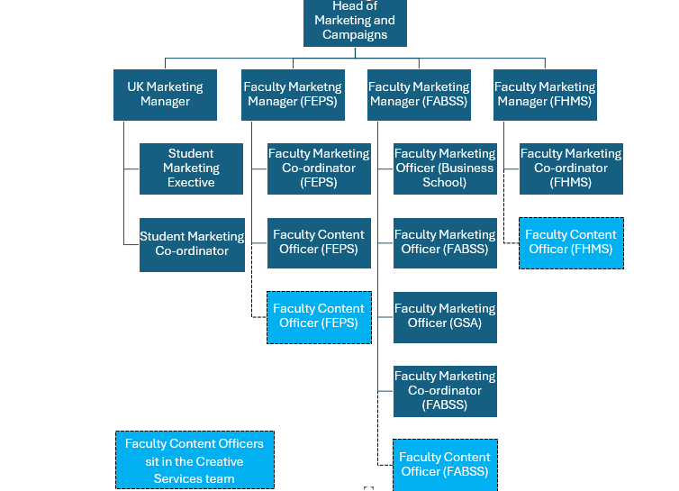

Background Information

The Marketing Team covers four areas: Student Marketing, Faculty Marketing, Digital and Data and International Recruitment.

The Division is responsible for ensuring that the University is optimally positioned in domestic and international markets against a variety of different target audiences ranging from prospective students, prospective parents, schools, businesses and public bodies. Attraction of appropriate high-quality students; brand management and achieving high levels of customer service are some of the performance indicators against which the department will be judged.

Relationships
The post holder will be expected to liaise and build relationships with the following teams in order to progress the partnership work:

Internal

- the Wider marketing team,
- Faculty support staff,
- Recruitment team,
- Admissions team,
- Student union and student ambassadors.

External
- Creative media suppliers
- Photographers
- Listings providers,
- Media partners,
- External design,
- Print agencies.

